~~Personal Insurance, Inc.~~

Shelly Cashman Access 2019 | Module 9: SAM Project 1a



~~Administering a Database System~~

# ~~GETTING STARTED~~

* ~~Open the file~~ **~~SC_AC19_9a_~~*~~FirstLastName~~*~~_1.accdb~~**~~, available for download from the SAM website.~~
* ~~Save the file as~~ **~~SC_AC19_9a_~~*~~FirstLastName~~*~~_2.accdb~~** ~~by changing the “1” to a “2”.~~

~~If you do not see the .accdb file extension in the Save As dialog box, do not type it. The program will add the file extension for you automatically.~~

* ~~To complete this SAM Project, you will also need to download and save the following data files from the SAM website onto your computer:~~

~~Support_AC19_9a_ClaimTypes.accdb~~

* ~~Open the~~ **~~_GradingInfoTable~~** ~~table and ensure that your first and last name is displayed as the first record in the table. If the table does not contain your name, delete the file and download a new copy from the SAM website.~~
* ~~PROJECT STEPS~~

1. ~~Personal Insurance, Inc. is a national company that insures homeowners and renters. As a regional manager, you need to understand database administration tasks. Open the database in Backstage View, and then click the~~ **~~View and edit database~~****~~properties~~** ~~link. When the Properties dialog box displays, create a custom property for the database as described below:~~
   1. ~~Create a custom property with~~ **~~Claim~~** ~~as the property name.~~
   2. ~~Select~~ **~~Date~~** ~~as the type.~~
   3. ~~Enter~~ **~~09/19/2019~~** ~~as the value.  
        
      Confirm that your custom property matches the one shown in Figure 1. (~~*~~Hint:~~* ~~Your database may contain other properties, depending on the version of Access used to open the file or the method by which the file was downloaded from SAM. Ignore these additional properties.) Click~~ **~~OK~~**~~.~~

* ~~Figure 1: Custom Properties Tab in the Properties Dialog Box~~

~~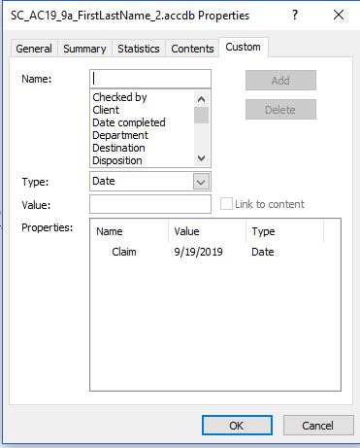~~

1. ~~With the database still open in Backstage View, click the~~ **~~Options~~** ~~tab. Select the~~ *~~Main Menu Navigation Form~~* ~~as the Display Form for the database as shown in Figure 2. (~~*~~Hint:~~* ~~The Display Form is sometimes referred to as the startup form.)  
   Save the changes to the options~~*~~. (Hint:~~* ~~When the Access dialog box appears and displays the message, "You must close and reopen the current database for the specified option to take effect", click the~~ **~~OK~~** ~~button.)~~

* ~~Figure 2: Access Options Dialog Box~~

~~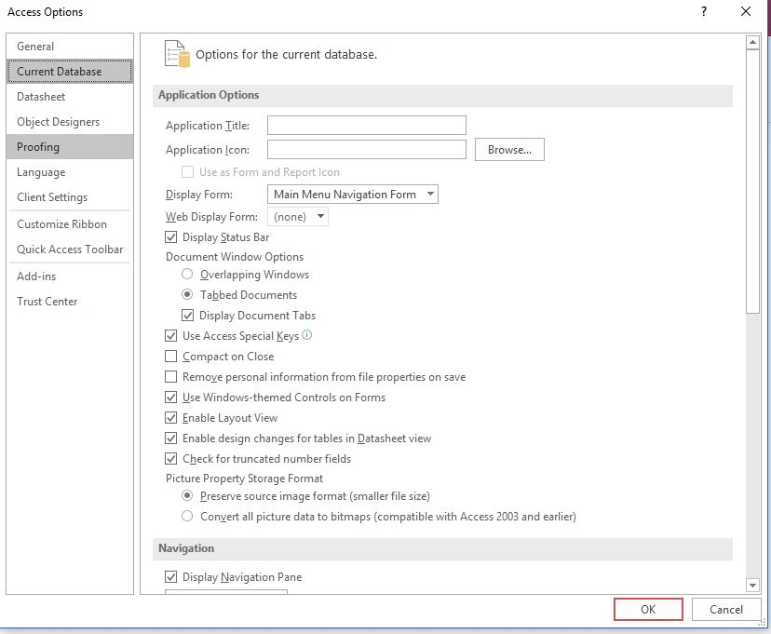~~

1. ~~Open the~~ *~~ClaimsRep~~* ~~table in Design View, and then create a custom input mask for the~~ *~~ClaimsRepNumber~~* ~~field as described below:~~
   1. ~~The~~ *~~ClaimsRepNumber~~* ~~field must consist of two letters and two numbers.~~
   2. ~~All letters should display in upper case. (~~*~~Hint~~*~~: Enter~~ **~~>LL99~~** ~~as the input mask.)~~
   3. ~~Save the changes to the table but do not close it.~~
2. ~~With the~~ *~~ClaimsRep~~* ~~table still open in Design View, modify the ClaimsRepName multiple-field index by completing the following tasks:~~
   1. ~~Open the Indexes dialog box.~~
   2. ~~Change the sort order for the~~ *~~LastName~~* ~~field to~~ **~~Descending~~**~~.  
        
      Save the changes to the~~ *~~ClaimsRep~~* ~~table and then close it.~~
3. ~~Open the Customers table in Design View, and then create a single-field index on the LastName field. The index should allow duplicate values. Save the changes to the table design but do not close the table.~~
4. ~~With the~~ *~~Customers~~* ~~table still open in Design View, create a multiple-field index as described below:~~
   1. ~~Use~~ **~~Location~~** ~~as the name of the index. (~~*~~Hint:~~* ~~Be careful not to include spaces after the index name.)~~
   2. ~~Use the~~ *~~State~~* ~~field, sorted in~~ **~~Descending~~** ~~order, as the first field in the index.~~
   3. ~~Use the~~ *~~City~~* ~~field, sorted in~~ **~~Ascending~~** ~~order, as the second field in the index.  
        
      Save the changes to the~~ *~~Customers~~* ~~table and then close it.~~
5. ~~Open the~~ *~~Claims~~* ~~table in Design View, and then open the Property Sheet for the table and make the following updates:~~
   1. ~~Create a validation rule for the table requiring that the~~ *~~Paid~~* ~~field value is always less than or equal to the~~ *~~ClaimAmount~~* ~~field value. (~~*~~Hint~~*~~: Enter~~ **~~[Paid]<=[ClaimAmount]~~** ~~as the validation rule.~~
   2. ~~Enter~~ **~~Paid cannot exceed ClaimAmount~~** ~~as the validation text.  
        
      Close the Property Sheet, and then save the changes to the table. (~~*~~Hint:~~* ~~Because there was a change to data integrity rules, the "existing data may not be valid" warning message will appear. Click No and continue saving the table.)~~
6. ~~With the~~ *~~Claims~~* ~~table still open in Design View, create a multiple-field index as described below:~~
   1. ~~Use~~ **~~ClaimsInformation~~** ~~as the name of the index. (~~*~~Hint:~~* ~~Be careful not to include spaces after the index name.)~~
   2. ~~Use the~~ *~~CustomerID~~* ~~field, sorted in~~ **~~Ascending~~** ~~order, as the first field in the index.~~
   3. ~~Use the~~ *~~ClaimID~~* ~~field, sorted in~~ **~~Ascending~~** ~~order, as the second field in the index.  
        
      Save the changes to the~~ *~~Claims~~* ~~table, and then close it.~~
7. ~~Create a Datasheet form for the~~ *~~Umbrella~~* ~~table, and then save the form using~~ **~~UmbrellaForm~~** ~~as the form name. Close the form.~~
8. ***Create a blank form based on the 1 Right application part. (Hint: The blank form will appear in the Navigation Pane as a forms object named SingleOneColumnRightLabels and is saved automatically.)***
9. ~~Import a table from an encrypted database by completing the following tasks:~~
   1. ~~Open the encrypted database~~ **~~Support_AC19_9a_ClaimTypes.accdb~~** ~~in Exclusive mode, using the password~~ **~~claims~~** ~~when the Password Required dialog box appears. Enable the content.~~
   2. ~~Decrypt the~~ **~~Support_AC19_9a_ClaimTypes.accdb~~** ~~database. (~~*~~Hint~~*~~: You will need to use the password~~ **~~claims~~** ~~again in the Unset Database Password dialog box.) Close the database.~~
   3. ~~Open (or return to) the~~ **~~SC_AC19_9a_FirstLastName_2.accdb~~** ~~database.~~
   4. ~~Import the~~ *~~ClaimTypes~~* ~~table from the database~~ **~~Support_AC19_9a_ClaimTypes.accdb~~** ~~into a new table using~~ **~~ClaimTypes~~** ~~as the table name. (~~*~~Hint~~*~~: Ensure that the Tables tab is selected in the Import Objects dialog box.)~~
   5. ~~Do not save the Import steps.~~
10. ~~Use the Table Analyzer to analyze the~~ *~~Customers~~* ~~table for redundancy. Implement the following options when using the Table Analyzer Wizard:~~
    1. ~~Select the~~ *~~Customers~~* ~~table as the table to analyze, and let the wizard decide what fields go in each table.~~
    2. ~~Rename Table 1 as~~ **~~AltCustomers~~** ~~using the Rename table button as shown in Figure 3.~~
    3. ~~Rename Table 2 as~~ **~~AltRegion~~** ~~using the Rename table button as shown in Figure 3.~~
    4. ~~When the wizard displays the next screen with the question, "do the bold fields uniquely identify each record in the proposed table", make sure the~~ *~~CustomerID~~* ~~field is the primary key of the~~ *~~AltCustomer~~* ~~table as shown in Figure 3. Then, click the Next button.~~
    5. ~~Ensure that the "No, don't create the query" radio button is selected, then click Finish to close the Table Analyzer Wizard.~~
    6. ~~When the Table Analyzer Wizard dialog box appears with the message, "The command or action TileHorizontally isn't available now", click OK. Close the~~ *~~AltCustomers~~* ~~and~~ *~~AltRegion~~* ~~tables.  
         
       Confirm the Navigation Pane matches Figure 4.~~

* ~~Figure 3: Table Analyzer Wizard~~

~~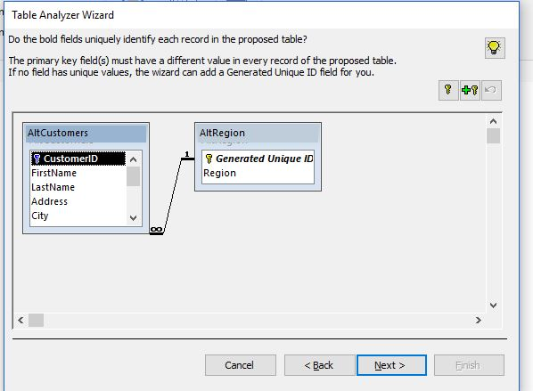~~

* ~~Figure 4: Navigation Pane with Tables Created in Step 12~~

~~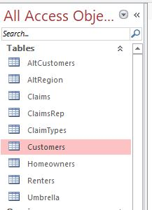~~

1. ~~Switch to viewing database items by the custom category named "Claims Information" in the Navigation Pane. Add the following two forms to the Claims Information Forms group:~~
   1. *~~Claims Master Form~~*
   2. *~~ClaimsRep and Claims Form~~* ~~Confirm the Claims Information Forms group matches Figure 5.~~
2. ~~Add a new group to the Claims Information category as described below:~~
   1. ~~Use~~ **~~Claims Reports~~** ~~as the name for the new group.~~
   2. ~~If necessary, move the Claims Reports group so that it appears between the Claims Information Forms and the Unassigned Objects groups.~~
   3. ~~In the Navigation Pane, add the~~ *~~Basic Claims Report~~* ~~to the new group.  
        
      Confirm the Claims Reports group and item in the Navigation Pane match Figure 5.~~

* ~~Figure 5: Navigation Pane Viewed by Claims Information Category~~

~~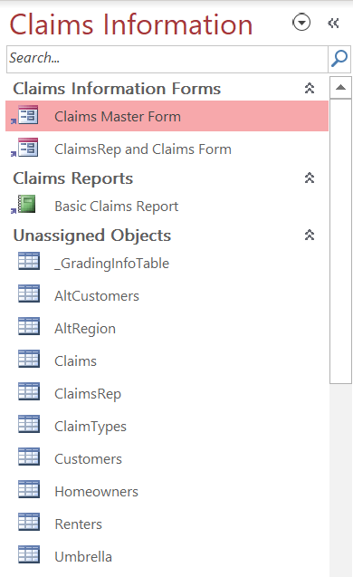~~

Save and close any open objects in your database. Compact and repair your database, close it, and then exit Access. Follow the directions on the SAM website to submit your completed project.